*Project Name*: **The MAP MY FOOD** Website Project

Executive Summary: The Map My Food Website project aimed to develop a user-friendly and efficient online platform for ordering food from various restaurants and delivering it to customers' doorsteps. The website was designed to provide a seamless experience for both customers and restaurant owners, offering a wide range of food options, convenient ordering and payment methods, and timely delivery services. The project was successfully completed within the specified timeline and budget, meeting the primary objectives and delivering a high-quality food delivery website.

**Key Project Objectives:**

1. Develop a user-friendly and visually appealing website interface.
2. Integrate with multiple restaurants and provide a comprehensive menu selection.
3. Implement a secure and efficient ordering and payment system.
4. Facilitate real-time order tracking and delivery status updates.
5. Ensure compatibility across various devices and browsers.
6. Optimize website performance and loading speed.
7. Provide a seamless and intuitive user experience.

**Project Deliverables:**

1. Food Delivery Website:
   * Home page showcasing featured restaurants, popular dishes, and promotions.
   * Restaurant listing page with search and filter options.
   * Individual restaurant pages with menus, ratings, and customer reviews.
   * User registration and login functionality.
   * Secure ordering and payment system.
   * Real-time order tracking and delivery status updates.
   * User profile management.
   * Customer support and feedback system.
2. Admin Panel:
   * Dashboard for managing restaurants, menus, and orders.
   * Order tracking and management functionality.
   * Restaurant and menu management tools.
   * Customer support management.
   * Analytics and reporting features.

**Project Highlights:**

1. User-Friendly Interface: The website features an intuitive and visually appealing design, allowing users to easily navigate through the platform and browse restaurants, menus, and offers effortlessly.
2. Extensive Restaurant Integration: The website successfully integrated with a wide range of local restaurants, providing customers with a diverse selection of cuisines and dining options.
3. Seamless Ordering and Payment: A secure and efficient ordering and payment system was implemented, allowing customers to place orders conveniently and make payments using various methods, including credit/debit cards, digital wallets, and cash on delivery.
4. Real-Time Order Tracking: The website incorporated a real-time order tracking feature, enabling customers to monitor their orders from the moment they are placed until they are delivered.
5. Responsive Design: The website was optimized for compatibility across different devices and browsers, ensuring a consistent user experience regardless of the platform used.
6. Performance Optimization: The website's performance was optimized to provide fast loading times, enhancing user satisfaction and reducing bounce rates.

**Project Challenges:**

1. Integration Complexity: Integrating with multiple restaurants and their varied menus posed a technical challenge, requiring extensive coordination and data management.
2. Delivery Logistics: Coordinating delivery services with different restaurants and managing delivery timeframes presented logistical challenges that required careful planning and coordination.
3. Payment Security: Ensuring a secure payment system that protected users' financial information and prevented fraudulent activities required robust security measures and compliance with industry standards.

**Conclusion**: The Map My Food Website project successfully accomplished its objectives by delivering a user-friendly, feature-rich, and efficient platform for ordering food online. The website provides a seamless experience for customers, allowing them to explore a wide range of restaurants, place orders, track deliveries, and provide feedback. The project team demonstrated strong technical expertise in web development, overcoming challenges related to integration complexity, delivery logistics, and payment security. The completed website is poised to become a leading platform for food delivery, serving customers and restaurant owners alike.

Top of Form

**CODING**

<html>

<head>

    <title> MMF </title>

<link rel="stylesheet" type="text/css" href="styles.css" />

</head>

<body onload="myFunction()" style="background-color: rgba(79, 129, 189, 0.9);">

<div id="loading"></div>

<div class="header">

    <img src="C:\Users\THEJASHWINI\Documents\newproj\mmf_logo.png">

    <form style="float: none;display:inline-block;line-height:52px;padding-right:140px;">

        <input type="text" name="searchbar" placeholder="search.." size="70" >

    </form>

        <input type="checkbox" id="show">

        <label for="show" class="show-btn">Login</label>

        <div class="container">

            <div class="text">

                <form action="#">

                    <div class="data">

                        <label>Login ID</label>

                        <input type="text" required>

                    </div>

                    <div class="data">

                        <label>Password</label>

                        <input type="password" required>

                    </div>

                    <div class="btn">

                        <div class="inner"></div>

                        <button type="submit">LOGIN</button>

                    </div>

                </form>

            </div>

        </div>

</div>

<br>

<center><img src="https://images.unsplash.com/photo-1540189549336-e6e99c3679fe?ixlib=rb-4.0.3&amp;ixid=MnwxMjA3fDB8MHxwaG90by1wYWdlfHx8fGVufDB8fHx8&amp;auto=format&amp;fit=crop&amp;w=987&amp;q=80" width="250" height="237"></center>

<style>

    .blink {

        animation: blinker 1.5s linear infinite;

        color: yellow;

        font-family: sans-serif;

    }

    @keyframes blinker {

        50% {

            opacity: 0;

        }

    }

</style>

<marquee class="blink" direction="right">

    <h1>READY TO PLACE YOUR ORDER..</h1>

    </marquee>

<div class="row">

    <div class="column">

        <a href="C:\Users\THEJASHWINI\Documents\newproj\mapmyfood_bf.html"><h2 align="center">BREAKFAST</h2></a>

        <img src="https://images.pexels.com/photos/36744/agriculture-arable-clouds-countryside.jpg?auto=compress&amp;cs=tinysrgb&amp;w=1260&amp;h=750&amp;dpr=1" width="110" height="100">

    </div>

    <div class="column">

        <a href="C:\Users\THEJASHWINI\Documents\newproj\mapmyfood_ln.html"><h2 align="center">LUNCH</h2></a>

        <img src="https://images.unsplash.com/photo-1605226469551-f5833ca74dcf?ixlib=rb-4.0.3&amp;ixid=MnwxMjA3fDB8MHxwaG90by1wYWdlfHx8fGVufDB8fHx8&amp;auto=format&amp;fit=crop&amp;w=1032&amp;q=80" width="110" height="100">

    </div>

    <div class="column">

    <a href="C:\Users\THEJASHWINI\Documents\newproj\mapmyfood_bf.html"><h2 align="center">DINNER</h2></a>

<img src="https://images.pexels.com/photos/3489072/pexels-photo-3489072.jpeg?auto=compress&amp;cs=tinysrgb&amp;w=1260&amp;h=750&amp;dpr=1" width="110" height="100">

</div>

</div>

<script>

    var preloader = document.getElementById('loading');

    function myFunction(){

        preloader.style.display='none';

    }

</script>

<br><br>

<footer>

    <select name="country" id="country">

        <option value="INDIA">India</option>

        <option value="CHINA">China</option>

        <option value="AMERICA">America</option>

        <option value="RUSSIA">Russia</option>

        <option value="JAPAN">Japan</option>

        <option value="KOREA">Korea</option>

      </select>

    <br>

    <a href="C:\Users\THEJASHWINI\Documents\newproj\FOOTER.html"><h3>FEEDBACK</a></h3>

</footer>

</body>

</html>

<html>

<head>

<title> MAP MY FOOD </title>

</head>

<body style = "background-color: brown;">

    <h1 style="color:aliceblue;background-color: rgb(170,170,21);text-align: center;">MAP MY FOOD</h1>

    <center><img src="https://images.unsplash.com/photo-1546069901-ba9599a7e63c?ixlib=rb-4.0.3&amp;ixid=MnwxMjA3fDB8MHxwaG90by1wYWdlfHx8fGVufDB8fHx8&amp;auto=format&amp;fit=crop&amp;w=880&amp;q=80" width="250" height="230"></center>

    <br>

    <img id="details-enlarged-image" class="js-search-result-thumbnail responsive-img container--focus" src="https://as1.ftcdn.net/v2/jpg/05/05/40/28/1000_F_505402811_prL7D5Go35LZKpQeUVEUiCLnO6spS3sk.jpg" width="210" height="200" alt="Indian food Masala dosa" itemprop="thumbnail" data-content-id="505402811">

    <a href="C:\Users\THEJASHWINI\Documents\newproj\DOSAform24.html"> <h1>DOSA</h1></a>

    <img src="https://st.depositphotos.com/2340703/3381/i/600/depositphotos_33812263-stock-photo-idly-with-tomato-chutney.jpg" width="210" height="200">

    <h1> IDLY</h1>

    <img src="https://www.shutterstock.com/image-photo/indian-street-foods-whole-wheat-260nw-1809081952.jpg" width="210" height="200">

    <h1>CHAPPATHI</h1>

    <img src="https://i0.wp.com/blendofspicesbysara.com/wp-content/uploads/2021/07/PXL_20210712_211207957.PORTRAIT-01.jpeg?resize=800%2C840&amp;ssl=1" width="210" height="200">

    <h1>PONGAL</h1>

    <img src="https://as2.ftcdn.net/v2/jpg/00/61/49/29/1000_F_61492902_ofekoulucb3nHtU7VkWlw1WK8xvXVh09.jpg" width="210" height="200">

    <h1>POORI</h1>

    <img src="https://as2.ftcdn.net/v2/jpg/04/29/14/57/1000_F_429145755_ypSrUGscbnM4RcD1ub07JvBjuNAv1Rfp.jpg" width="210" height="200">

    <h1> IDIYAAPAM</h1>

    <img src="https://media.istockphoto.com/id/1254720533/photo/chicken-biryani-with-yogurt-dip-popular-indian-pakistani-non-vegetarian-food.jpg?s=1024x1024&amp;w=is&amp;k=20&amp;c=LRHmocgo262PDMHpPwtJOdQi59ZkmigvgH8Xleu4vzs=" width="210" height="200">

    <h1>CHICKEN BRIYANI</h1>

    <img src="https://media.istockphoto.com/id/980036908/photo/gosht-or-lamb-biryani-prepared-in-basmati-rice-served-with-yogurt-dip-in-terracotta-bowl.jpg?s=1024x1024&amp;w=is&amp;k=20&amp;c=3ZSUuA6nf9xmdX3pWyTcb7iGTme8HudkXOe3bUJDl-c=" width="210" height="200">

    <h1>MUTTON BRIYANI</h1>

    <img src="https://images.pexels.com/photos/2338407/pexels-photo-2338407.jpeg?auto=compress&amp;cs=tinysrgb&amp;w=1260&amp;h=750&amp;dpr=1" width="210" height="200">

    <h1>CHICKEN</h1>

    <img src="https://as2.ftcdn.net/v2/jpg/00/72/30/17/1000_F_72301759_VvZee0ImkzsDYKAKKYDsPa8HY09CdZsy.jpg" width="210" height="200">

    <h1>MUTTON</h1>

    <img src="https://thumbs.dreamstime.com/z/vegetarian-schezwan-noodles-vegetable-hakka-noodles-chow-mein-black-bowl-dark-background-schezwan-noodles-indo-159221461.jpg" width="210" height="200">

    <h1>VEG NOODLES</h1>

    <img src="https://www.shutterstock.com/image-photo/sambar-rice-south-indian-food-260nw-1771868309.jpg" width="210" height="200">

    <h1>SAMBAR RICE</h1>

    <img src="https://media.vogue.in/wp-content/uploads/2020/11/Gobhi-Manchurian-recipe-chinese-starters.jpg" width="200" height="200">

    <h1>GOBI MANCHURIAN</h1>

    <img src="https://media.istockphoto.com/id/1273291313/photo/delicious-veg-peas-pulao-rice.jpg?s=1024x1024&amp;w=is&amp;k=20&amp;c=z2gaXQ5FZ7DU7wWNNPtq1tEQNfbs4ru7Ssfxug5N2sI=" width="210" height="200">

    <h1>VEG BRIYANI</h1>

    <img src="https://rakskitchen.net/wp-content/uploads/2014/01/11919320035_1f6dd4da79_z.jpg" width="210" height="200">

    <h1>MINI IDLY</h1>

</body>

</html>

#loading{

  position: fixed;

  width: 100%;

  height: 100vh;

  background: #Fff

  url('file:///C:/Users/THEJASHWINI/Documents/newproj/Preloader/amalie-steiness.gif')

   no-repeat center ;

  z-index: 99999;

}

.header{

  width:100%;

  height:60px;

  background-color:#E6E6FA;

}

.header img{

  float: left;

  width: 150px;

  height: 100px;

}

.header input{

  height: 50px;

  font-size: large;

}

.header label{

    float: inline-end;

    top: 50%;

    left: 50%;

    transform: translate(-50%, -50%);

}

body{

  height: 100vh;

  text-align: center;

}

  /*Trigger Button*/

.login-trigger {

  font-weight: bold;

  color: #fff;

  background: linear-gradient(to bottom right, #B05574, #F87E7B);

  padding: 15px 30px;

  border-radius: 30px;

  position: relative;

  top: 50%;

}

.show-btn{

  background: #fff;

  padding: 10px 20px;

  font-size: 20px;

  font-weight: 500;

  color: #3498db;

  cursor: pointer;

  box-shadow: 0px 0px 10px rgba(0,0,0,40);

}

.container{

  position: absolute;

  top: 50%;

  left: 50%;

  transform: translate(-50%, -50%);

}

input[type="checkbox"]{

  display: none;

}

.container{

  display: none;

  background: #fff;

  width: 410px;

  padding: 30px;

  box-shadow: 0 0 8px rgba(0,0,0,40);

}

#show:checked ~ .container{

  display: block;

}

.container .close-btn{

  position: absolute;

  right: 20px;

  top: 15px;

  font-size: 18px;

  cursor: pointer;

}

.container .close-btn:hover{

  color: #3498db;

}

.container .text{

  font-size: 35px;

  font-weight: 600;

  text-align: center;

}

.container form{

  margin-top: -20px;

}

.container form .data{

  height: 45px;

  width: 100%;

  margin: 40px 0;

}

form .data label{

  font-size: 18px;

}

form .data input{

  height: 100%;

  width: 100%;

  padding-left: 10px;

  font-size: 17px;

  border: 1px solid silver;

}

form .data input:focus{

  border-color: #3498db;

  border-bottom-width: 2px;

}

form .btn{

  margin: 30px 0;

  height: 45px;

  width: 100%;

  position: relative;

  overflow: hidden;

}

form .btn .inner{

height: 100%;

width: 300%;

position: absolute;

left: -100%;

z-index: -1;

transition: all 0.4s;

background: -webkit-linear-gradient(right, #56d8e4, #9f01ea, #56d8e4, #9f01ea);

}

form .btn:hover .inner{

  left: 0;

}

form .btn button{

  height: 100%;

  width: 100%;

  background: none;

  border: none;

  color: #fff;

  font-size: 18px;

  font-weight: 500;

  letter-spacing: 1px;

  cursor: pointer;

}

.login {

  padding: 6px 20px;

  border-radius: 20px;

  background: none;

  border: 2px solid #FAB87F;

  color: #FAB87F;

  font-weight: bold;

  transition: all .5s;

  margin-top: 1em;

}

.login:hover {

  background: #FAB87F;

  color: #fff;

}

.column{

  float: left;

  width: 33.33%;

  padding: 0px;

}

.row::after{

  content: "";

  clear: both;

  display: table;

}

body, html {

    height: 100%;

    text-align: center;

}

body {

  background-color: #242F3F;

}

.loader {

  display: inline-block;

  width: 30px;

  height: 30px;

  position: relative;

  border: 4px solid #Fff;

  animation: loader 2s infinite ease;

}

.loader-inner {

  vertical-align: top;

  display: inline-block;

  width: 100%;

  background-color: #fff;

  animation: loader-inner 2s infinite ease-in;

}

@keyframes loader {

  0% {

    transform: rotate(0deg);

  }

  25% {

    transform: rotate(180deg);

  }

  50% {

    transform: rotate(180deg);

  }

  75% {

    transform: rotate(360deg);

  }

  100% {

    transform: rotate(360deg);

  }

}

@keyframes loader-inner {

  0% {

    height: 0%;

  }

  25% {

    height: 0%;

  }

  50% {

    height: 100%;

  }

  75% {

    height: 100%;

  }

  100% {

    height: 0%;

  }

}

footer{

  width:100%;

  height:60px;

  background-color:#E6E6FA;

}

select{

  float: left;

  width: 20%;

  height: 80%;

  background: #FAB87F;

  font-size: larger;

}

$(document).ready(function(){

        window.setTimeout('fadeout();', 10s);

    });

    function fadeout(){

        $('#loader').delay(5s).fadeOut('slow', function() {

           $('.notLoaded').removeClass('notLoaded');

        });

    }

**RESULT**

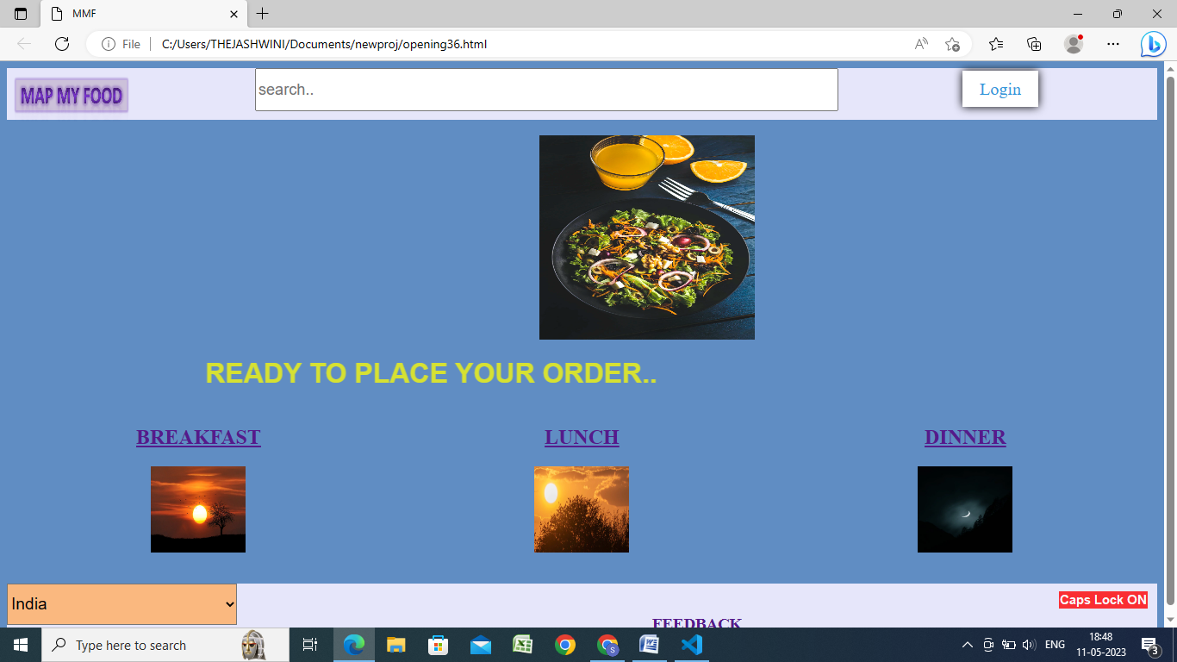

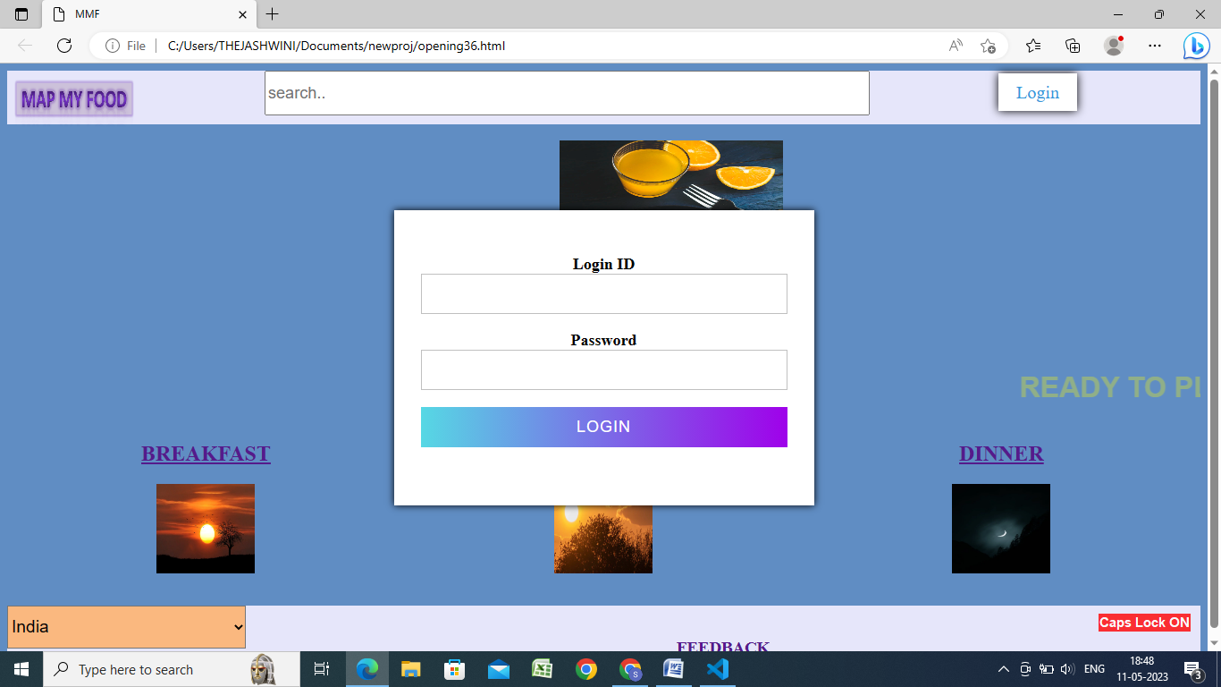

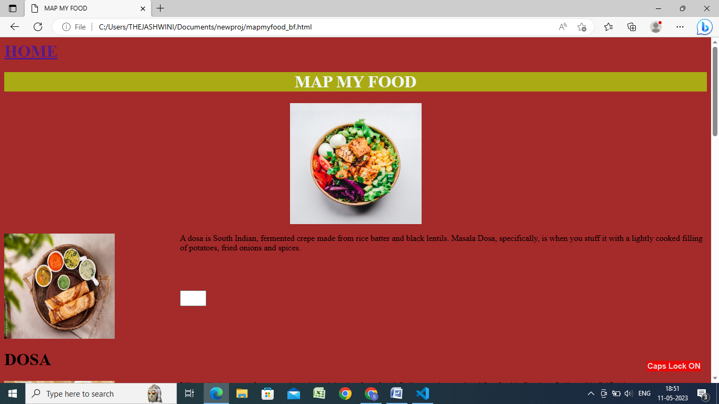

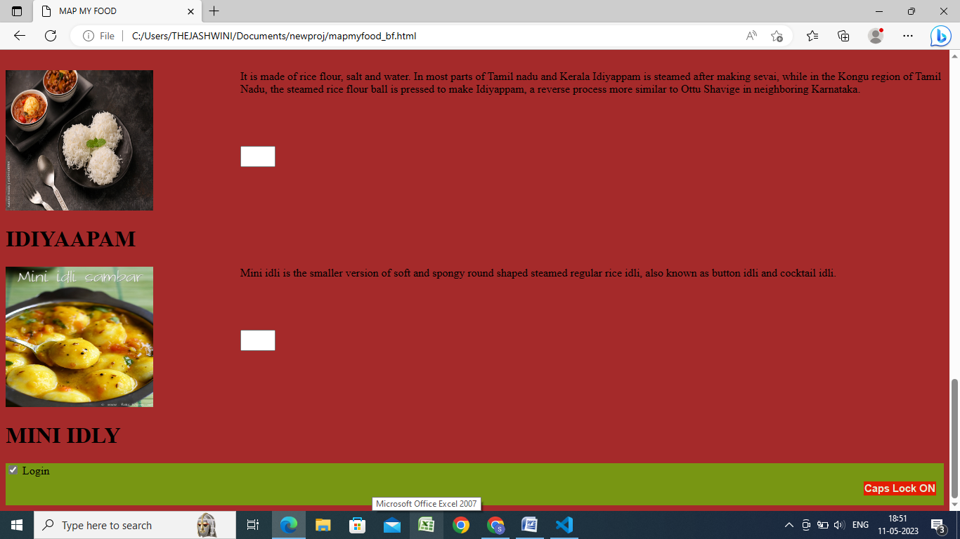

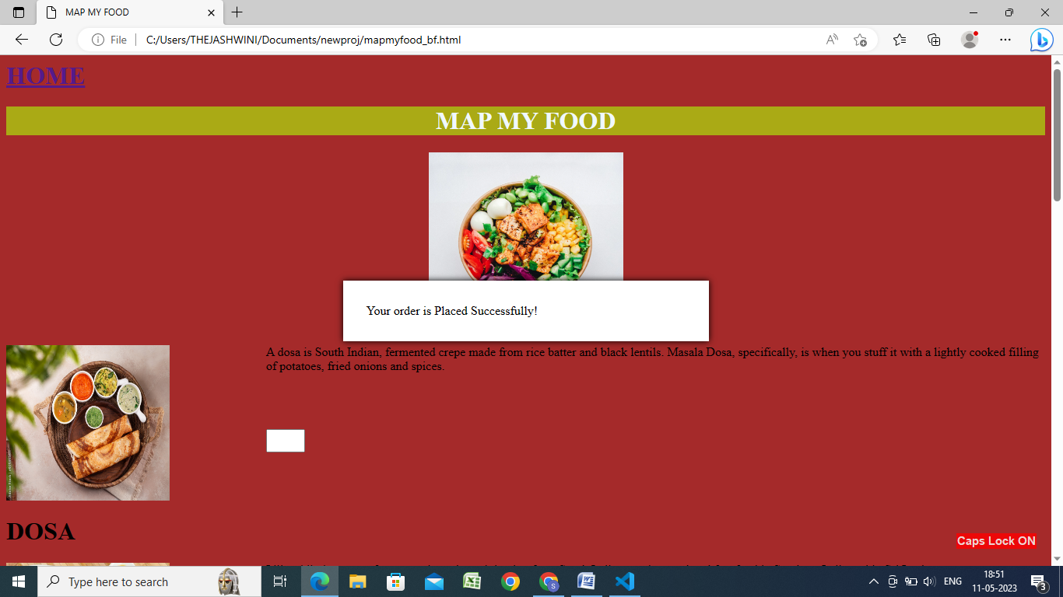

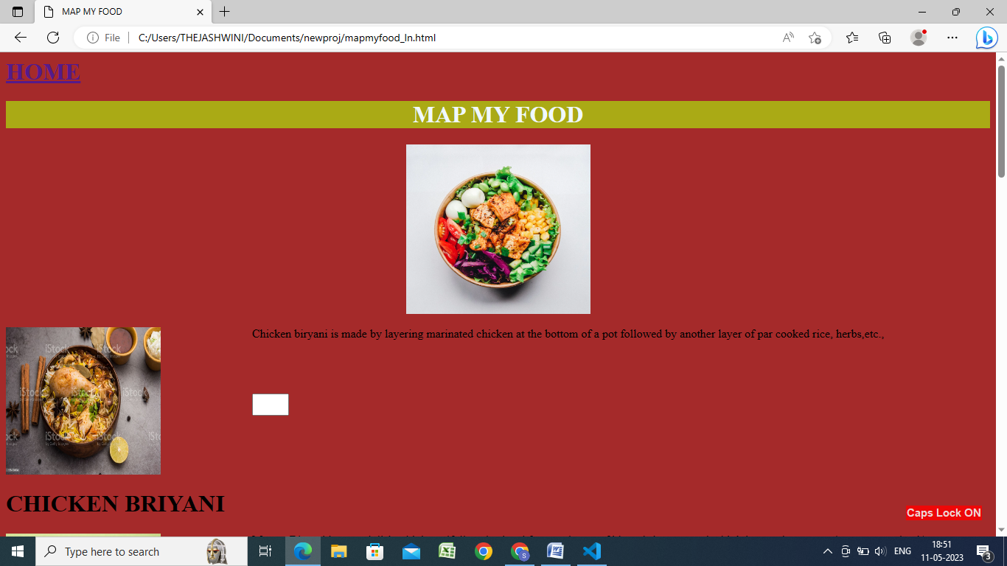

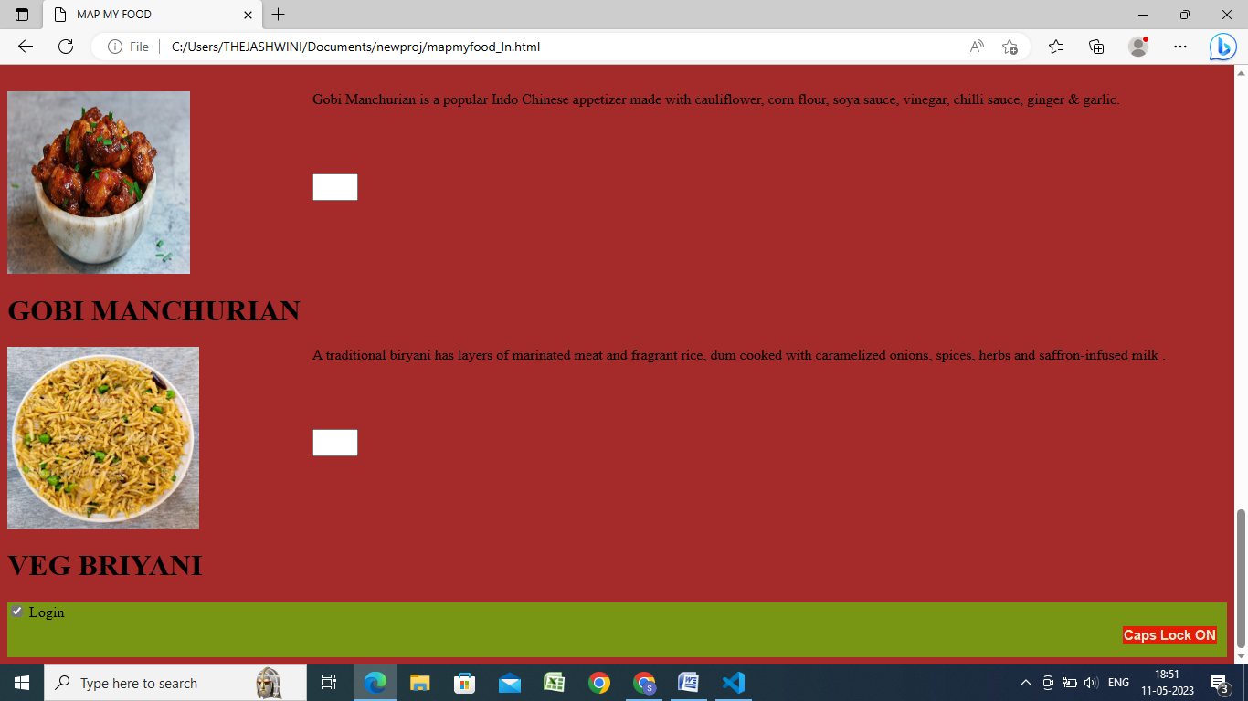

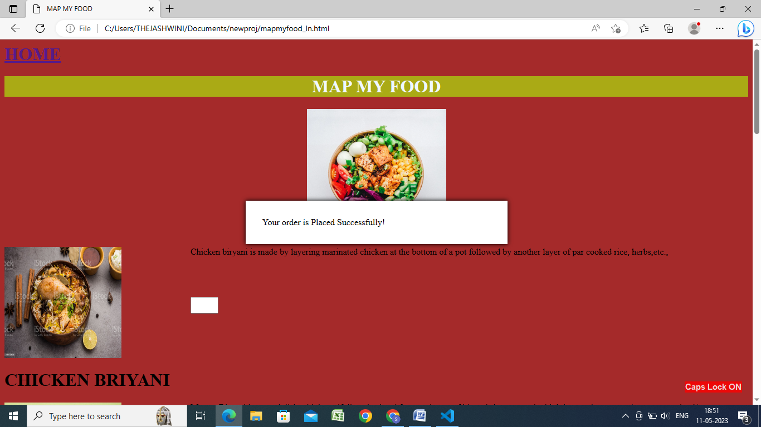

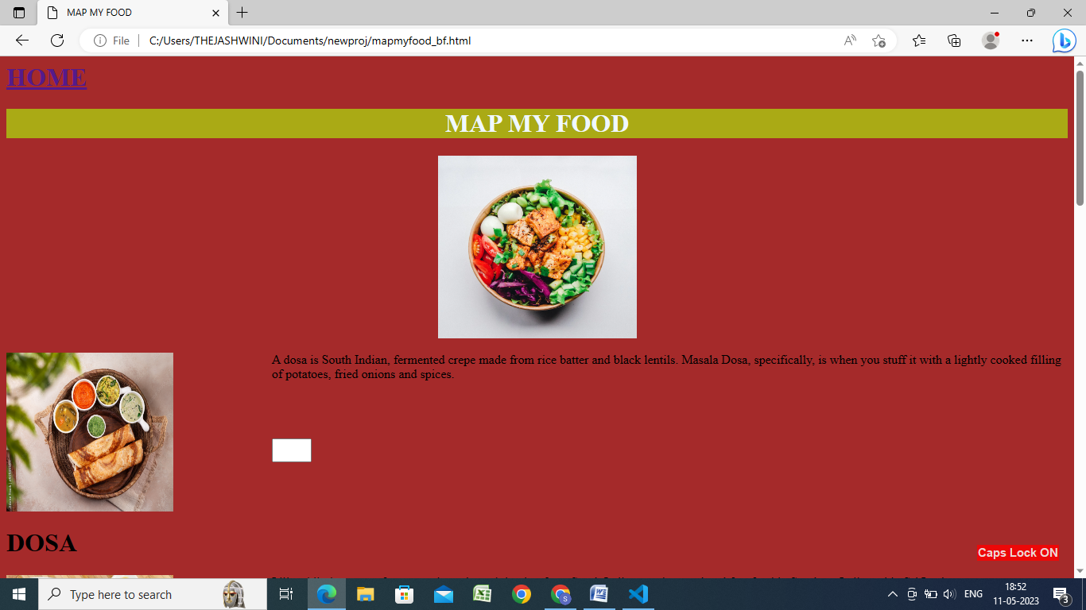

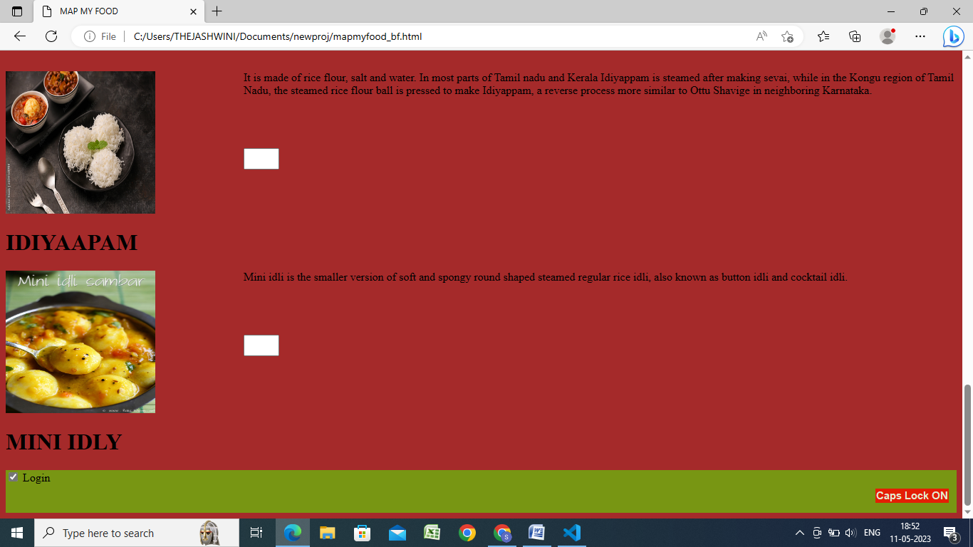

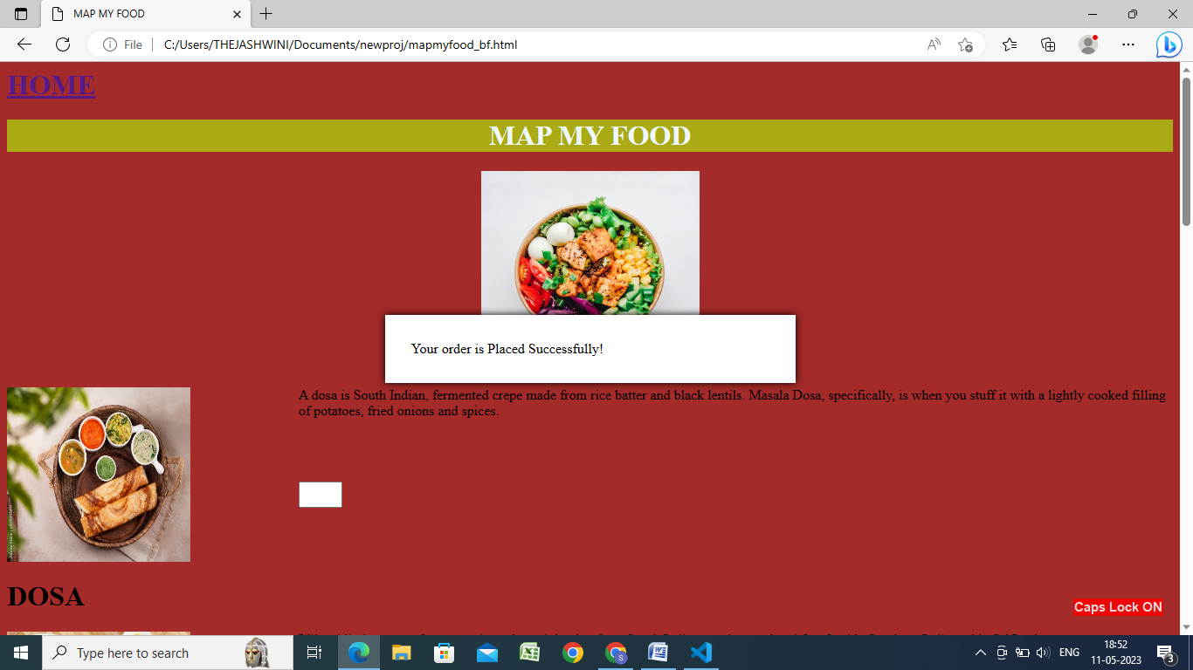

**PROJECT DONE BY**

***SANJAII KRISHNAN S A***

***B.Tech – AI&DS***